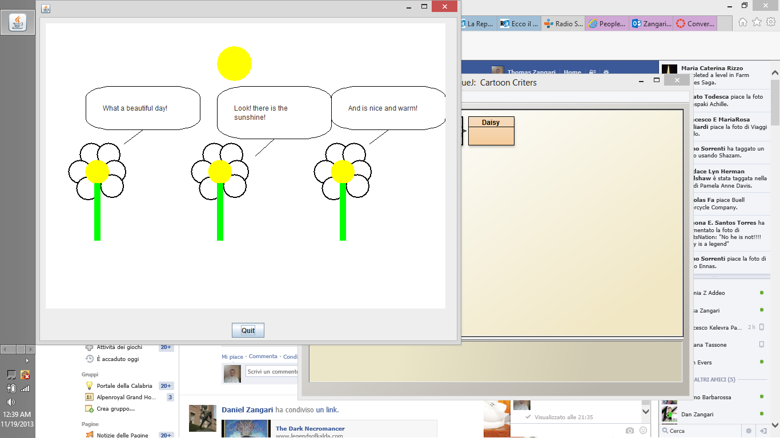

/**

* Write a description of class SnowPeople here.

*

* @author (thomas zangari)

* @version (11/19/2013)

*/

import wheels.users.*;

public class DaisyPicture extends Frame{

// instance variables - replace the example below with your own

private Rectangle _stem;

private Daisy _daisy1,_daisy2,_daisy3;

private Ellipse _sun;

private ConversationBubble _bubble1;

private ConversationBubble _bubble2;

private ConversationBubble _bubble3;

public DaisyPicture() {

_daisy1 = new Daisy(70,240);

_daisy2 = new Daisy( 285, 240);

_daisy3 = new Daisy (500,240);

_sun = new Ellipse(java.awt.Color.yellow);

_sun.setLocation(300,40);

_sun.setSize(60,60);

_bubble1 = new ConversationBubble("What a beautiful day!",ConversationBubble.TAIL_DIR_LEFT);

_bubble2 = new ConversationBubble("Look! there is the sunshine!",ConversationBubble.TAIL_DIR_LEFT);

_bubble3 = new ConversationBubble("And is nice and warm!",ConversationBubble.TAIL_DIR_LEFT);

_bubble1.setLocation(70,110);

_bubble2.setLocation(300,110);

_bubble3.setLocation(500,110);

}

public static void main(String[] args){

DaisyPicture picture = new DaisyPicture();

}

}

----------------------------------------------------------------------------------------------------------------------------------------------------------------------------------------------------------------------------------------------------------------------------------

/**

* Write a description of class Dayse here.

*

* @author (thomas zangari)

* @version (11/19/2013)

*/

import wheels.users.*;

import java.awt.Color;

public class Daisy

{

// instance variables - replace the example below with your own

private Rectangle _stem;

private Ellipse _petal1,_petal2,_petal3,_petal4,_petal5,_petal6;

private Ellipse _center;

private int _x, _y;

/**

* Constructor for objects of class Dayse

*/

public Daisy(int x, int y){

_petal1 = new Ellipse();

_petal2 = new Ellipse();

_petal3 = new Ellipse();

_petal4 = new Ellipse();

_petal5 = new Ellipse();

_petal6 = new Ellipse();

_center = new Ellipse();

_stem = new Rectangle();

_x = x;

_y = y;

this.setColor(Color.WHITE);

this.setSize();

this.setLocation(x,y);

this.setOutline(java.awt.Color.black,2);

// initialise instance variables

}

public void setColor ( Color petalColor){

_petal1.setColor(petalColor);

_petal2.setColor(petalColor);

_petal3.setColor(petalColor);

_petal4.setColor(petalColor);

_petal5.setColor(petalColor);

_petal6.setColor(petalColor);

_center.setColor(java.awt.Color.YELLOW);

_stem.setColor(java.awt.Color.GREEN);

}

public void setSize(){

_petal1.setSize(40,40);

_petal2.setSize(40,40);

_petal3.setSize(40,40);

_petal4.setSize(40,40);

_petal5.setSize(40,40);

_petal6.setSize(40,40);

_center.setSize(40,40);

_stem.setSize(10,100);

}

public void setOutline(java.awt.Color color,int thickness){

_petal1.setFrameColor(color);

_petal1.setFrameThickness(thickness);

_petal2.setFrameColor(color);

_petal2.setFrameThickness(thickness);

_petal3.setFrameColor(color);

_petal3.setFrameThickness(thickness);

_petal4.setFrameColor(color);

_petal4.setFrameThickness(thickness);

_petal5.setFrameColor(color);

_petal5.setFrameThickness(thickness);

_petal6.setFrameColor(color);

_petal6.setFrameThickness(thickness);

_center.setFrameThickness(thickness);

}

public int getX(){

return _x;

}

public int getY(){

return _y;

}

public void setLocation(int x,int y){

_x = x;

_y = y;

_petal1.setLocation(_x-10,_y-30);

_petal2.setLocation(_x+20,_y-30);

_petal3.setLocation(_x+30,_y);

_petal4.setLocation(_x-30,_y);

_petal5.setLocation(_x+26,_y+25);

_petal6.setLocation(_x-16,_y+29);

_stem.setLocation(_x+15,_y+40);

_center.setLocation(x,y);

}

}